**NAME:** CAROLINE NYAMBURA WACHIRA

**EMAIL:** caroline.nyambura@womentechsters.org

**DATE OF SUBMISSION**: 11TH JUNE 2021.

**QUESTION 1**

**Write the code in a file created in your home directory and call it authentic .sh**

**ANSWER**

**NB: The steps listed below is in line with the attached screenshot, I am using Kali Linux**

1.Start by writing Present working directory (PWD) to know where you are in the terminal, press enter and type in LS to see the files that you have in your documents or desktop.

2.Then change command to desktop or documents depending on where you want to create your file at, I will change my command to desktop, by typing in” cd Desktop” in the terminal.

3.Create a new file by typing in mkdir on the terminal my file will be called Turtle, so I will type in “mkdir Turtle “press enter and Type in” LS” to see whether it has been listed in the desktop files.

4. Change command to the file name that you created that is “cd Turtle”

5.Create a file named” authentic.sh “by typing” nano authentic.sh” it will take you to the nano editor.

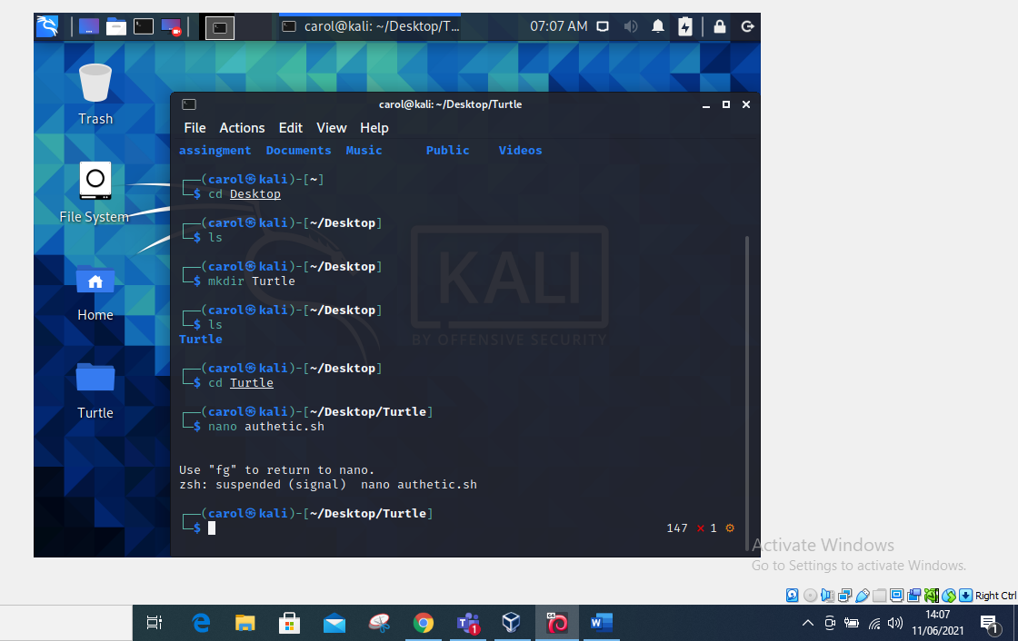

**QUESTION 2**

**Just the same way we have created scripts execute it and use nano editor to add your code**

**ANSWER**

1.once in the terminal you can press fg to return to the nano editor.

2.Since we will be writing the script to the bash shell the first line will be #! /bin/bash

3.we will then echo “enter password “and read the password. Hence type in the length by writing len=” $ {#password}”

4. I finally execute my commands in nano reader authentic.sh, please find the attached

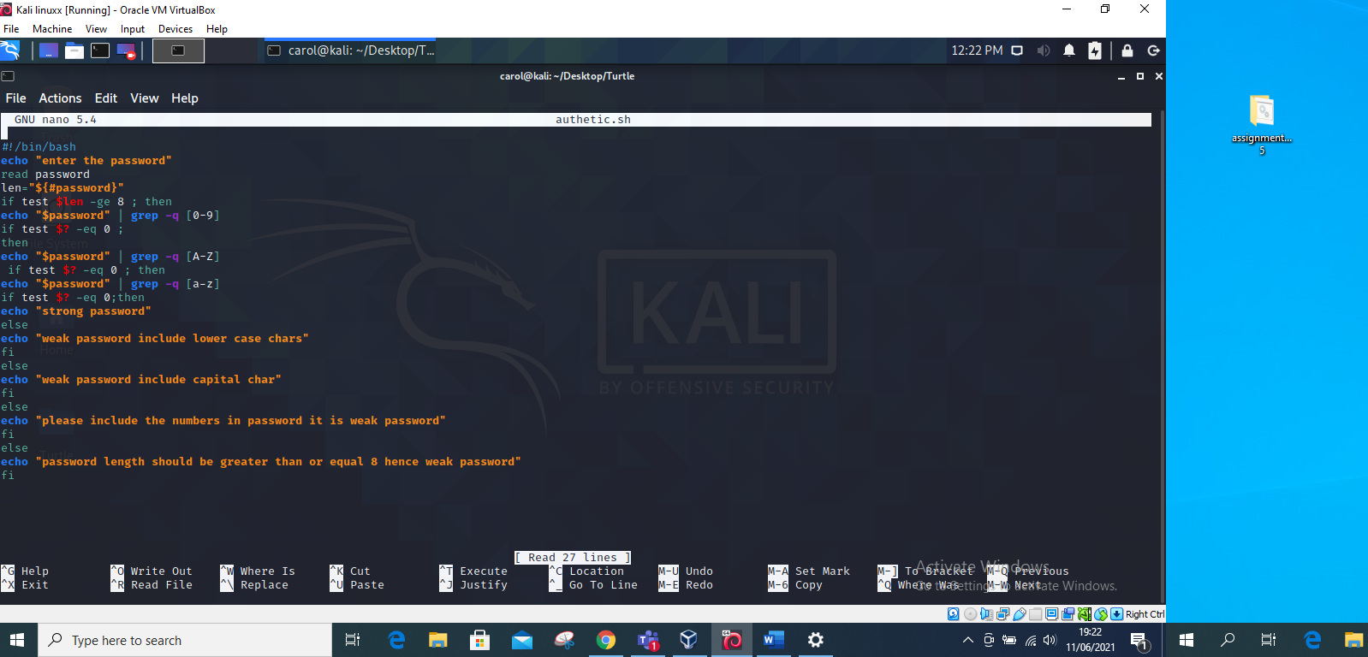

**5 I finally tried running some commands and it works out**

1. I start by running the password with less than characters find the attached.

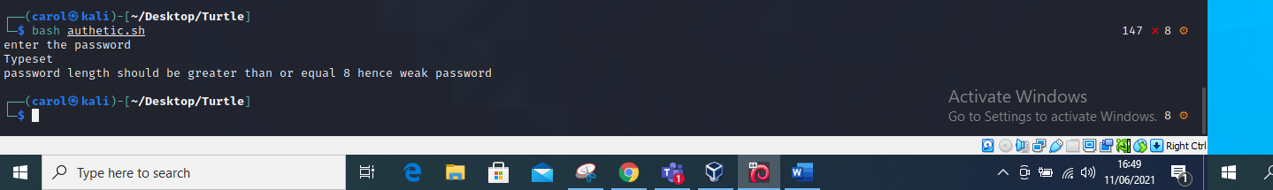

B. I run the password without numerical figures

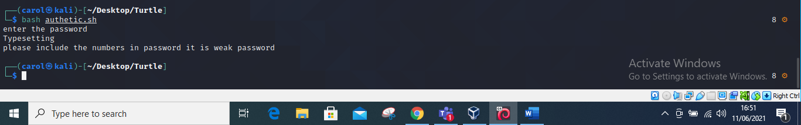

C. I run the password without any upper-case letters.

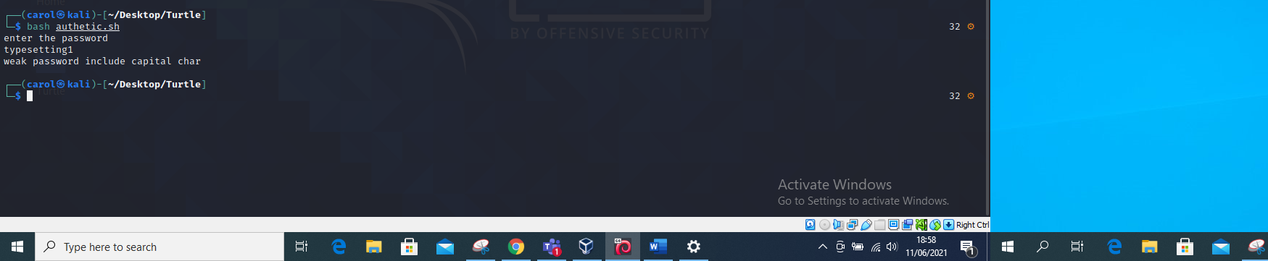

D. I run the password without any small letters

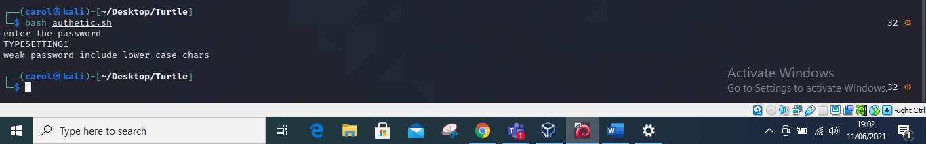

E. Tried a strong password including all characters

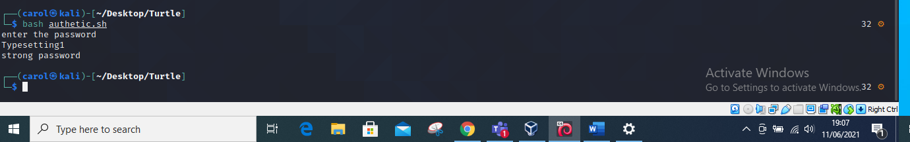

F. Tried a password that included commas and other symbols e.g. commas, @,# , and it emerges it is a strong password.

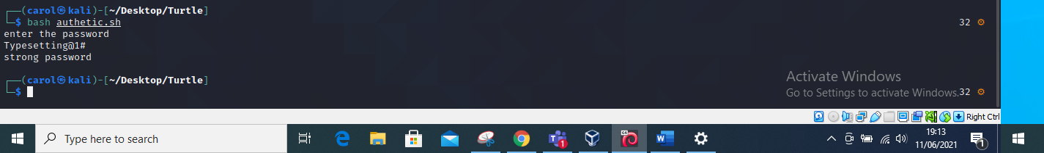

G. Tried a password with less characters less than 8 and included symbols e.g. @, #, commas

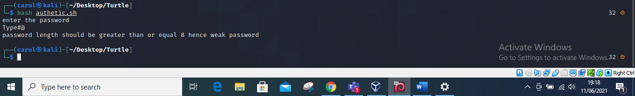

**END**